**Assignment-7**

**Uploading a Static Website on an Amazon EC2 Server:**

**Step 1: Setting Up an EC2 Instance**

1. Log in to the AWS Management Console and navigate to the EC2 dashboard.
2. Click **Launch Instance** to create a new virtual server.
3. Configure the instance as follows:
   * **Name**: Provide a meaningful identifier (e.g., MyWebServer).
   * **Amazon Machine Image (AMI)**: Select Ubuntu (Free Tier eligible).
   * **Instance Type**: Choose t2.micro (Free Tier eligible).
4. Set up the Key Pair for authentication:
   * Use an existing key pair or create a new one.
   * If creating a new one, download the .pem file and store it securely.
5. Configure Security Group settings:
   * Allow **SSH (22)** for remote access.
   * Allow **HTTP (80)** and **HTTPS (443)** for web traffic.
6. Review and launch the instance.
7. Once the instance is running, retrieve the **Public IPv4 Address** for later use.

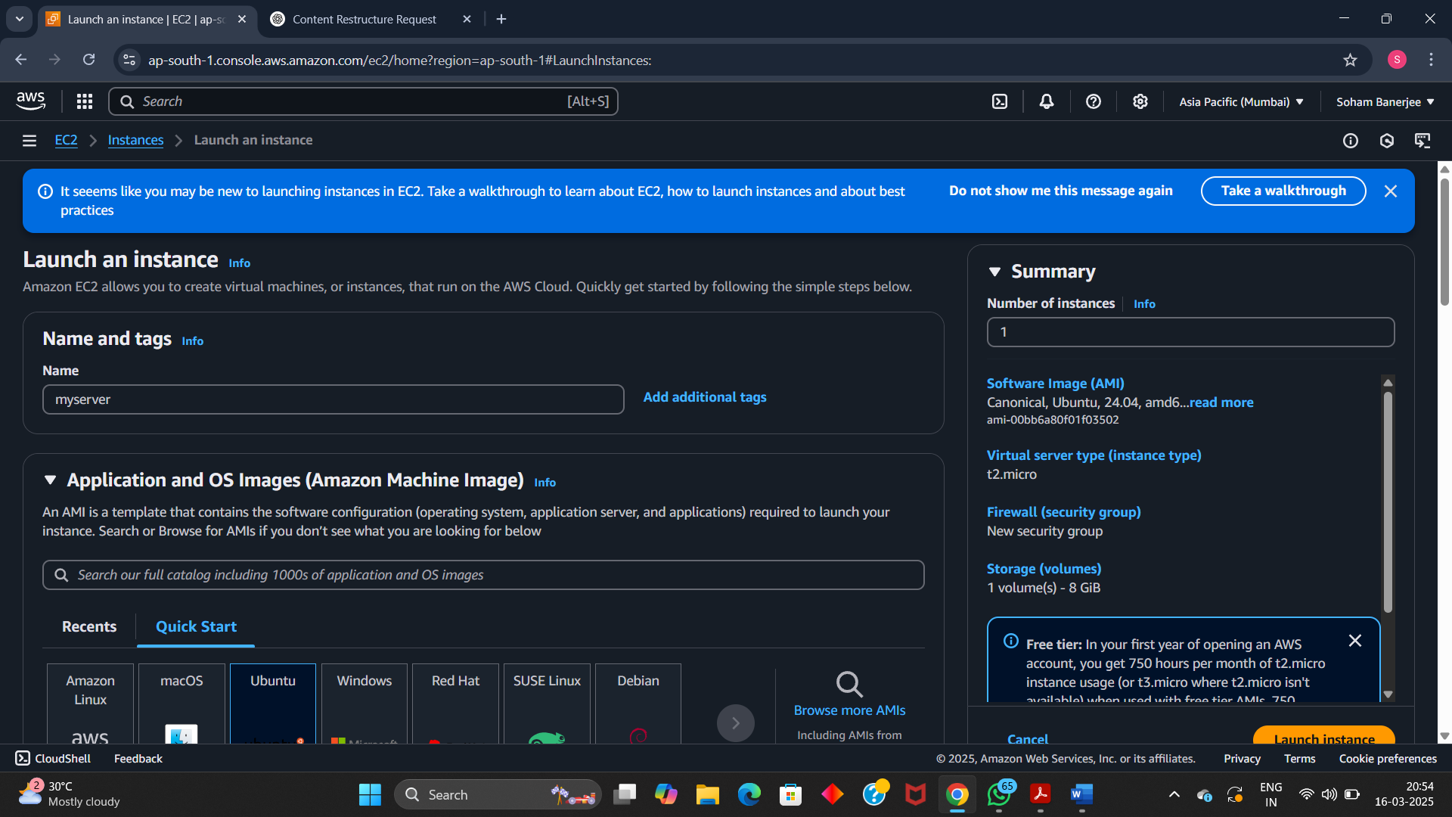

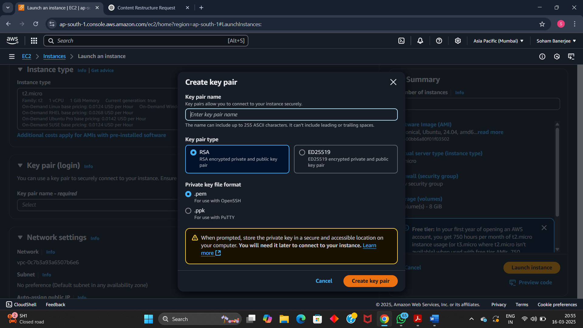

**Step 2: Connecting to the EC2 Instance**

1. Copy the Public IPv4 Address of your instance.
2. Install an SSH client like **Bitvise SSH Client** (or use an alternative like PuTTY or terminal SSH).
3. Configure the SSH client:
   * **Host**: Enter the Public IPv4 Address.
   * **Username**: ubuntu
   * **Authentication Method**: Public key (upload the .pem file).
4. Open a terminal within the SSH client and update the package lists:
5. sudo apt-get update && sudo apt-get upgrade
   * When prompted, type y and press Enter.

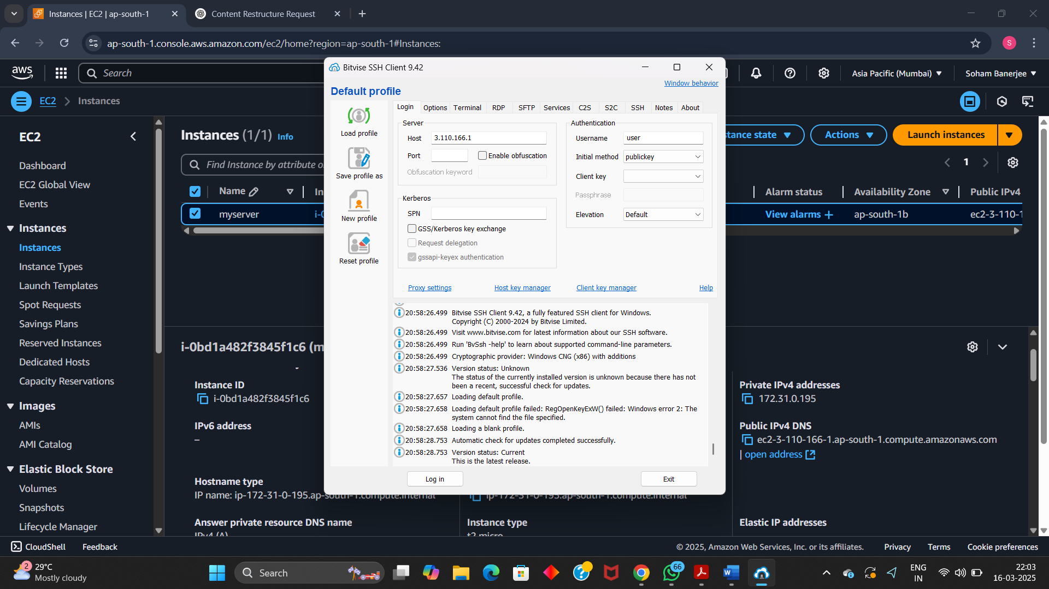

**Step 3: Installing and Configuring NGINX**

1. Install NGINX using the command:
2. sudo apt-get install nginx
   * Confirm installation by typing y when prompted.
3. Verify that NGINX is installed:
4. nginx -v
   * The output should display the installed version of NGINX.

**Step 4: Uploading Website Files**

1. Open an **SFTP** client within the SSH software.
2. Locate your local static website files (e.g., index.html, about.html).
3. Navigate to the EC2 instance’s web directory:
4. /var/www/html
5. Modify file permissions if needed:
6. sudo chmod 777 /var/www/html
7. Upload your static files by dragging them into the /var/www/html directory.

**Step 5: Testing the Website**

1. Open a web browser.
2. Enter the **Public IPv4 Address** of your instance in the address bar.
3. Press **Enter**.
4. Your website should now be visible, indicating a successful deployment.